Self-Assessment-Yuchen Li

*• Critically analyze/evaluate how much time was spent learning syntax & structure, programming concepts vs. actually programming, and how does this reflect on the final quality of your end result.*

1. I learned my programming concepts mostly in class, the object and class structure saved my time.
2. For this project, it mainly used 2D-array, so I still take time to learn. Even though the idea of using 2D-array was inspired from other’s [project](https://editor.p5js.org/ARatherLongUsername/sketches/SkxeigFOX). Also, I tried to use single index array to replace 2D-array, but it does not work well to access color of blocks and the position changes made by mouse movement.
3. Also, I learned a lot of shortcuts of conditions. If ((a===1)&&(b===1))is same as if (a===1&&b===1). I also learned from others’ codes and understand them, comment them, and edit them. Some edits I feel is better than before.
4. Overall, I feel I took very long time to learn and think about this project, and most time I use p5 editor, which can appear the result when I was programming it. While learning and programing I enjoyed taking time to resolve bugs and thinking new methods in my project. It makes my project complex, but playful.
5. I usually do it at night, think about its logic and elements before sleeping, and write down all my ideas on paper. These notes really helped me.
6. Github updates is a good way to backup the code. It saved my life! Also, I feel it is not necessary to update 10 times in a day, I only need to update the final version of a day.

*• Comment on your successes and frustrations with Processing and P5.js.*

1. Successes: I learned both languages, and I can write programs. Maybe something I still don’t know of these two, but I can always look up in references and understand the function, class, methods etc. The best thing is that I have learned how to learn and use a new language. It will be so helpful for my future learning.

*• Compare and contrast OOP versus Procedural Programming.*

1. OOP is objective-oriented Programming, it is more about setting up the class with objects, methods and then activate each method in the loop, with different conditions.
2. Procedural Programming is more like the function based, conditionally do things.
3. In this project, I used both, I set up the class and objects and methods, and also set up different functions to interactive with mouse, screen size, score, and other conditions.

*• Specifically considering your final project: What programming concepts solidified in your final project? What did you learn with reference to programming? Did you have a break through?*

1. In final project, the main thing I learned is 2D-array and array methods. I found that there are few methods listed on the reference page of P5.js, so I have to search them from JavaScript references. Also, when I was doing the restart button, I found it is difficult to reset millis(), the program running time to 0. I learned so much new knowledge of P5, in this project. For the block colors and shapes, I defined them by using objects and arrays.
2. In this project, I feel 2D-array is so convenient to change the object’s positions. Also, it is able to change the coordinates of the object by equations. Tetris is a little bit more difficult than I thought to be. But the basic ideas of its movements and game mechanics are easy.

• Specifically considering your final project: Were you able to resolve your own bugs? What tricks did you learn in the process to help? Did you do any debugging?

1. Yes, in this project, I resolve many bugs:
   1. The bug that two blocks overlap
   2. The bug that blocks out of grid
   3. The bug that when there is no space move up once and then overlap with another block
   4. The bug that when player hit space, it finds the space from bottom to top (then it became another mode of the game)
   5. The bug that when game is over, it has errors before I call the loop stop.
   6. The bug that background music plays in each loop.
   7. Many infinite loops, and it really broke my desktop.
   8. The bug that if you change your screen size the project doesn’t show properly.
   9. The bug that if you change your screen size the mouse position and the objects’ position changed and caused mouse cannot click on the objects.

• How do you think you'll move forward with programming? will you keep doing it? How does this relate to other classes you are either taking or wish to take?

1. I will practice and do more with p5 and processing. The way of learning new things in programing is enjoyable. In the future courses, I will keep the habits of updating project weekly.

Documentation of final project:

• Take several screen shots of application running. In fact, shoot a short video of the screen. Get good, crisp, well lit, clear shots.

[](2019-12-16%2002-10-17.mp4)

• copy and pasted 2-3 screen shots of code into Sublime that you are most proud of.

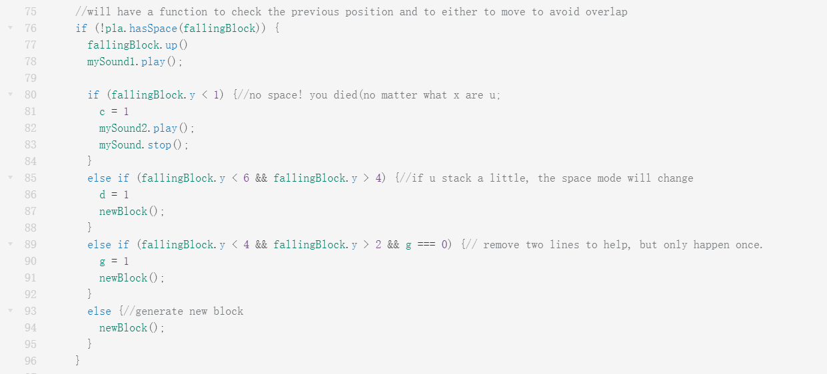

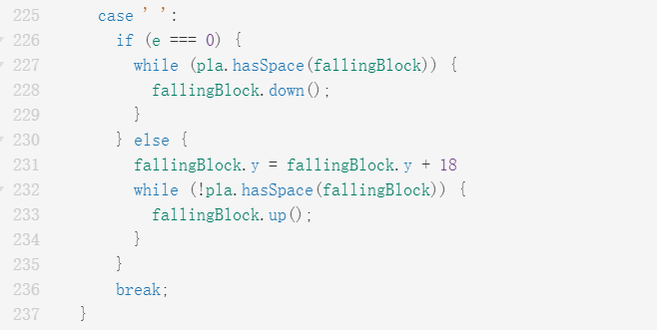

• concept paragraph answering the following: What is your piece about? What's the concept? Is it interactive, responsive or time based?, name of piece

1. For the first piece, it is about the dead conditions, helps appeared conditions and block stopped conditions. These all depends on their y-coordinates that they will stay. Then the variables c, is a “switch” of game over text and end the game. D is the cat help and switches to another space mode, and g controls the panda. Notice that the panda help also has the condition g is 0, after using once panda’s help, players cannot see another panda’s help.
2. The second one is the space key to make block fall more quickly. The second part used to be the original code I wrote for the drop. However, it has some bugs that pieces can drop to the end directly even though they should not (the example is in the video). It is also my first time to use while function, even though it caused several times of crashes.